**Project Design Phase-II**

**Data Flow Diagram & User Stories**

|  |  |
| --- | --- |
| Date | **15 October 2022** |
| Team ID | **PNT2022TMID41308** |
| Project Name | **Project – SMART WASTE MANAGEMENT FOR METROPOLITAN CITIES** |
| Maximum Marks | **4 Marks** |

**Data Flow Diagrams:**

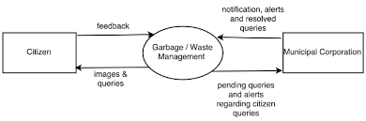

**Data Flow Diagram (level 0):**

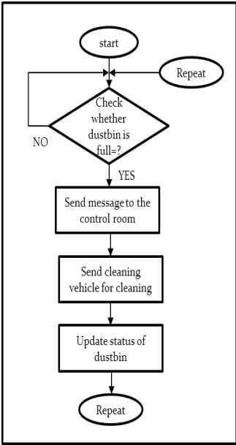

**User Stories:** List all the user stories for the product:

| **User Type** | **Functional Requirement (Epic)** | **User Story Number** | **User Story / Task** | **Acceptance criteria** | **Priority** | **Release** |
| --- | --- | --- | --- | --- | --- | --- |
| Customer (Mobile user) | Registration | USN-1 | As a user, I can register for the application by entering my email, password, and confirming my password. | I can access my account / dashboard | High | Sprint-1 |
|  |  | USN-2 | As a user, I will receive confirmation email once I have registered for the application | I can receive confirmation email & click confirm | High | Sprint-1 |
|  |  | USN-3 | As a user, I can register for the application through Facebook | I can register & access the dashboard with Facebook Login | Low | Sprint-2 |
|  |  | USN-4 | As a user, I can register for the application through Gmail | I can register & access the dashboard with Gmail | Medium | Sprint-1 |
|  | Login | USN-5 | As a user, I can log into the application by entering email & password | I can access easily to go dashboard | High | Sprint-1 |
|  | Interface | USN-6 | As a user, the interface should be user friendly manner | I can access the application easily | High | Sprint-1 |
| Customer (Web user) | Dashboard | WUSN-1 | As a Web user, I can register & access the specific information (map, level of bins, weight, etc…) | I can easily monitor the truck location | High | Sprint-1 |
| Customer Care Executive | View manner | CCE-1 | As a customer care, I can view the data in graphical representation | I can easy to view the status of the truck location, levels of bins | High | Sprint-1 |
|  | Detector | CCE-2 | As a customer care, I can detect the bins (volume) | I can detect the bins (volume) easily | High | Sprint-1 |
|  | Monitor | CCE-3 | As a customer care, I can monitor the truck location | I can easily monitor the location of the truck | Medium | Sprint-1 |
| Administrator | Risk Tolerant | ADMIN-1 | As an Administrator, who can handle the system update & take care of the application | Admin should monitor the system properly | High | Sprint-2 |